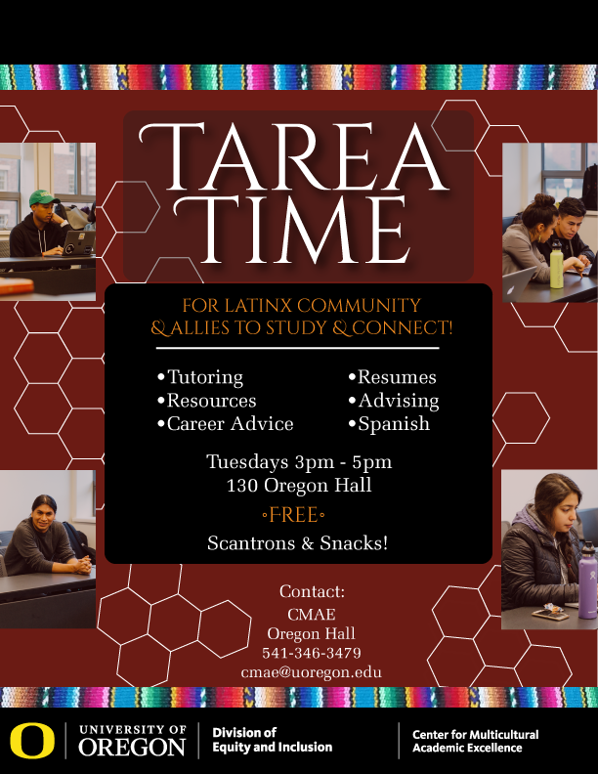**LSG Meeting 9/5/18 – Chiles 125B**

12:00 - 12:15 Introductions/Announcements/Updates

* Tarea Time:
  + Tuesdays 3-5, 130 Oregon Hall (CMAE)
  + Signup sheet: *Karla will send out link to sign up if you are interested in attending (holding office hours there, etc.)*
  + *Helpful to let students know who will be there each week*
  + *Might also be a good idea to schedule specific kinds of support for specific weeks (resumé support, librarian, etc.)*
  + *There will be a space in the new Tykeson Hall that we can reserve when it opens in Fall 2019*
* Latinx Heritage Month: starts September 15 <https://inclusion.uoregon.edu/latinx-heritage-month>
  + *In November, the main UO website will feature Latinx heritage (Día de los Muertos, student interviews, new Counseling Center staff, new Patos Alumni group)*
  + *October 22 – CLLAS will have screening of ‘Dolores’ & discussion, as well as a teach-in with Peter Bratt*
  + *Maybe next year, we can feature Heritage Month at a Ducks football game*
* Fiesta Cultural: by Lane Arts Council
  + *Stacy Ray from Lane Arts Council reached out to Sandra and CLLAS to see if they can maybe come to a meeting to make connections with the LSG and UO community*
  + Events September – December
  + Kickoff event: Friday, September 7th, 5:30-9:30 in Kesey Square (Downtown)
  + Find more info here: <http://lanearts.org/fiesta-cultural/> .

12:15 - 1:00 Agenda Items

* Fall Term incoming Co-Chair & notetaker:
  + in need of volunteers
  + *Note takers: Karla, Rosa*
* Ongoing Tasks: Check in
  + Developing LSG informational material/ Logo Creation
  + *Rosa shared example of business card from Mills Center to show what might be possible for LSG. Lorena has reached out to a student (Naily) who is willing to design a logo for us to use. In addition to the banner that is being made, these can be used for tabling.*
  + *We should discuss at the next meeting ways to make the business cards bilingual and how to translate the name of the group*
  + End of Year report
  + *It would be a good idea to generate a simple end-of-year report, especially to show to potential sponsors*
  + Moving listservs
  + *Patos Alumni Network listserv is too similar to ours, so we have a new listserv name. Rosa will send a survey to everyone on the current list to confirm that they still want to be on it.*
  + LSG scholarship funds disbursement
  + *Linda León in Romance Languages is the one who disburses these funds*
* HR New Employee Orientation:
  + Need 1-2 volunteers for October 2nd from 11:20-11:45 at FAC
  + *Asked all of the Strategy groups to share a table at this event so new employees can see the groups they can join; Rosa will be there*
  + Tabling at Resource Fairs on 1st Tuesdays of every month
  + *Sept 17, 3:30-4:15: Faculty Orientation in Knight Browsing Room; David will be tabling for the faculty union so maybe we can get a table for Strategy Groups too; someone needs to email Rachel at the Provost’s Office to ask*
* LSG Sponsorship Proposal:
  + JSMA’S Dia de Los Muertos Celebration – Nov 1 & 2
  + Cheryl Hartup – requesting $500
  + *Last year the JSMA had record attendance (>1500 people) and it was great to be able to feed everyone. DEI has contributed $500 to this year’s celebration, so Cheryl is asking for money from LSG to supplement that. LSG would be a sponsor and the group’s name/logo would be on all materials.*
  + *We voted by secret ballot (only those who have attended various meetings) – unanimous yes so it’s approved*
* *Eric and Michael from the Counseling Center shared about their new roles as Latinx Student Specialists and Kelsey shared about the kind of work she is doing at Planned Parenthood.*
* *Justine announced that there is a funder who has promised money for a DREAMer scholarship and we will be seeking funding to match the amount given. It should be available by winter or spring. Eventually it will be on DuckFund.*
* *Rosa is now on the Alumni Board so she’ll find out what is possible in terms of connections*
* *We discussed the possibility of having a fall meet and greet to get more faculty and staff who engage students in research to be involved and come to meetings – Lorena will reserve Falling Sky for Monday, October 1, 4-6 pm*
* *LSG is sponsoring a new Latinx ARC (Comunidad de Latinx Scholars) that will start in Earl Hall in fall 2019. Currently working with Housing to develop an informational card about the courses students will take. Michael Hames-García will be the Faculty Director. We still need to hire a Program Coordinator.*

**Next Meeting: October 3rd, 11-1, Location: TBD**

**New Structure**:

* Co-chairs: Fall Term (Rotating per term)
  + Incoming: ??
  + Outgoing: Sandra Castro (Creates agenda)
    - Agenda/Notes distributed via email to LSG
      * Note-takers: ??
    - OneDrive (to active LSG members w/UO email)
* Communications Committee
  + Meeting summary to Website/blog: <https://blogs.uoregon.edu/latinxstrategygroup/>
  + Announcements to Website/blog
  + Ed Wolf and Olga Sanchez ??
* Committees:
  + Cultural Events (Cultural Center? Lunes Latinx?)
  + Student Retention (ARC, Tarea Time, Scholarships)
  + Research (Grants)
  + Faculty Retention (Build relationships w/ UO & LCC)

**LSG Goals**:

* Short Term: Help institutionalize Tarea Time; increase relationship with UO Faculty. Create better relationships with LCC faculty/staff.
* Long Term: Create a Cultural Center, Scholarships, and Latinx ARC.

**LSG Sponsorship Funding**:

* [LSG Funding Request Link](https://oregon.qualtrics.com/jfe/form/SV_eg5LuID8cwRJmqp)
* [LSG Funds Assessment Survey](https://oregon.qualtrics.com/jfe/form/SV_agap79JxODlXAmF)