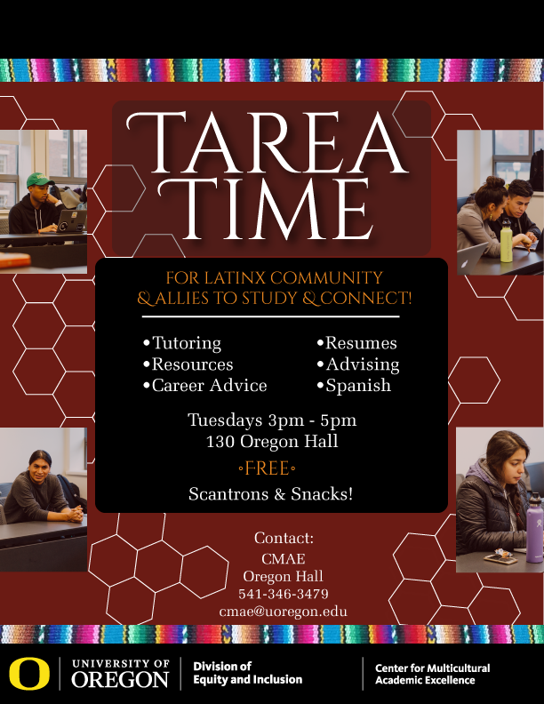**LSG Meeting 9/5/18 – Chiles 125B**

12:00 - 12:15 Introductions/Announcements/Updates

* Tarea Time:
  + Tuesdays 3-5, 130 Oregon Hall
  + Signup sheet: TBA
* Latinx Heritage Month: starts September 15 <https://inclusion.uoregon.edu/latinx-heritage-month>
* Fiesta Cultural: by Lane Arts Council
  + Events September – December
  + Kickoff event: Friday, September 7th, 5:30-9:30 in Kesey Square (Downtown)
  + Find more info here: <http://lanearts.org/fiesta-cultural/> .

12:15 - 1:00 Agenda Items

* Fall Term incoming Co-Chair & notetaker:
  + in need of volunteers
* Ongoing Tasks: Check in
  + Developing LSG informational material/ Logo Creation
  + End of Year report
  + Moving list serves
  + LSG scholarship funds dispersement
* HR New Employee Orientation:
  + Need 1-2 volunteers for October 2nd from 11:20-11:45 at FAC
  + Tabling at Resource Fairs on 1st Tuesdays of every month
* LSG Sponsorship Proposal:
  + JSMA’S Dia de Los Muertos Celebration – Nov 1 &2
  + Cheryl Hartup – requesting $500

**Next Meeting: October 3rd, 11-1, Location: TBD**

**New Structure**:

* Co-chairs: Fall Term (Rotating per term)
  + Incoming: ??
  + Outgoing: Sandra Castro (Creates agenda)
    - Agenda/Notes distributed via email to LSG
      * Note-takers: ??
    - OneDrive (to active LSG members w/UO email)
* Communications Committee
  + Meeting summary to Website/blog: <https://blogs.uoregon.edu/latinxstrategygroup/>
  + Announcements to Website/blog
  + Ed Wolf and Olga Sanchez ??
* Committees:
  + Cultural Events (Cultural Center? Lunes Latinx?)
  + Student Retention (ARC, Tarea Time, Scholarships)
  + Research (Grants)
  + Faculty Retention (Build relationships w/ UO & LCC)

**LSG Goals**:

* Short Term: Help institutionalize Tarea Time; increase relationship with UO Faculty. Create better relationships with LCC faculty/staff.
* Long Term: Create a Cultural Center, Scholarships, and Latinx ARC.

**LSG Sponsorship Funding**:

* [LSG Funding Request Link](https://oregon.qualtrics.com/jfe/form/SV_eg5LuID8cwRJmqp)
* [LSG Funds Assessment Survey](https://oregon.qualtrics.com/jfe/form/SV_agap79JxODlXAmF)