**LSG Meeting 4/4/18 - EMU 104, Coquille Room**

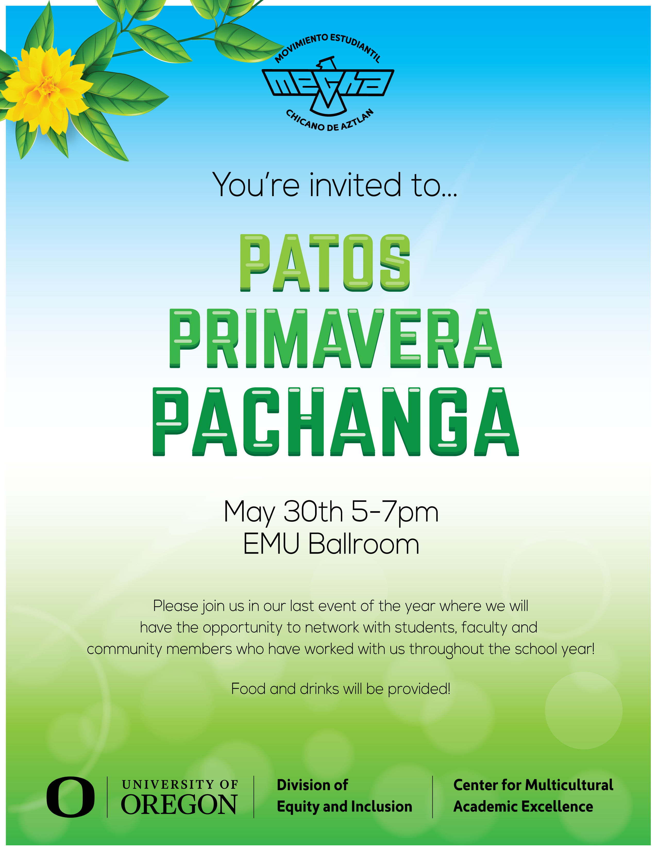

11:00- 11:30 Introductions/Announcements/Updates

* Career Center: Employee Relations Team
* Latinx Male Student & Allies Alliance (Angel Dorantes)
* Patos Primavera Pachanga (Karla Perez -Young)
  + May 30th, 5-7 pm, EMU Ballroom
* JCPenny Suit-Up event
  + April 15th, 11am-7pm
  + Extra 40% business apparel with Student ID
* UO IME Becas Scholarship
  + Eight $5,000 scholarships for Latinx/Dreamer Students
  + Minimum 2.7 cumulative GPA
  + Email with info & application sent through LSG list serve
    - Contact: Antonio Huerta ([joseh@uoregon.edu](mailto:joseh@uoregon.edu))

11:30- 12:00 Agenda Items

* Spring term check in:
  + In need of new incoming co-chair & note-takers
  + Update on funding request forms
* LSG Sponsorship Proposal:
  + "Black Latina The Play" by Crystal Roman, about the AfroLatinx experience
  + Latinx Heritage month performance
  + From Olga Sanchez Saltveit: “This could be a great way to connect with the Black Strategies Group and/or the Umoja ARC… I think the budget is $2000 total, not sure if that includes airfare, etc. This could of course, be considered for next year’s budget.”

12:00- 12:30 Breakout Committee Work – based on LSG Goals

1. **Faculty Committee:** Increase relationship with UO Faculty. Create better relationships with LCC faculty/staff.
2. **Research:** Grants, End of year report.
3. **Student Support:** ARC, Tarea Time, Scholarships

12:30 – 12:45 Committee Work Report Back

**Next Meeting: May 2nd – EMU 230, Swindells Room**

**New Structure**:

* Co-chairs: Spring Term (Rotating per term)
  + Incoming: ??
  + Outgoing: Creates agenda – Sandra Castro
    - Agenda/Notes distributed via email to LSG
      * Note-takers: Heather & Karla
    - OneDrive (to active LSG members w/UO email)
* Communications Committee
  + Meeting summary to Website/blog: <https://blogs.uoregon.edu/latinxstrategygroup/>
  + Announcements to Website/blog
  + Ed Wolf and Olga Sanchez
* Committees:
  + Cultural Events (Cultural Center? Lunes Latinx?)
  + Student Retention (ARC, Tarea Time, Scholarships)
  + Research (Grants)
  + Faculty Retention (Build relationships w/ UO & LCC)

**LSG Goals**:

* Short Term: Help institutionalize Tarea Time; increase relationship with UO Faculty. Create better relationships with LCC faculty/staff.
* Long Term: Create a Cultural Center, Scholarships, and Latinx ARC.