Spring 2018 Course Offerings

**MUS 359: Music of the Americas (4 credits)** Instructor: J.E. Wolf  
TR 12:00-1:20 PM + Discussion Section, Room: Clinical Services 250 (CLS 250)

[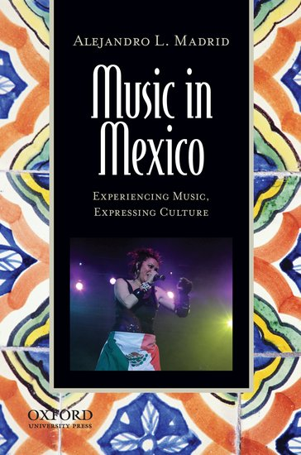](https://global.oup.com/academic/covers/pop-up/9780199812806)The Americas is a broad geographic expanse covering a range of cultures that is impossible to cover in-depth in a single academic term. There are ideas, however, that can help us bring important aspects of these cultures together: indigeneity, colonization, diaspora, and hybridity. Using these ideas, we will look at three countries and cultures in the Americas to see these ideas help us analyze music in these specific regions. No musical experience is necessary, but students will be asked to think through listening examples to understand why different musics sound the way they do. While we focus on three regions, the ideas are applicable throughout the Americas. This course fulfills the AC (American Cultures) Multicultural Requirement.

Selected Texts Include:

Selected Texts Include:  
Crook, Larry. 2009. Music of Northeast Brazil: Second Edition. Routledge: New York.  
Madrid, Alejandro. 2013. Music in Mexico. Oxford University Press: New York.  
Turino, Thomas. 2008. Music in the Andes. Oxford University Press: New York.

**MUS 410/610: Puerto Rican Music Ensemble (2 credits)** Instructor: J.E. Wolf  
M 5:00-6:20 PM plus half-hour sectional rehearsal, Room: World Music Ensemble Room, Gerlinger 119

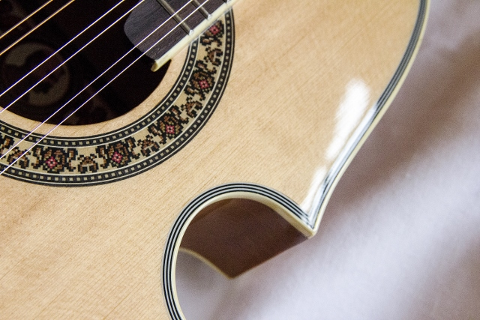One intellectual current within ethnomusicology is the idea of bi-musicality, or the ability to be fluent in more than one musical system. This course emphasizes the practice of music-dance from a specific region/culture and asks students to reflect on how this practice may compare with the musical systems they already have experience with. Students will be asked to take an embodied approach in learning. At the end of the term, students will share what they have learned with others through an end-of-term presentation. Students taking the class for additional credit (beyond 2.0 credits) are required to do additional work such as write an end-of-term research paper or produce a creative project related to region in question.

This term is dedicated to learning about the music-dance traditions of Puerto Rico. Several of these are drumming traditions that invite participation (bomba and plena), and everyone will learn a tune in these genres. We will also explore the jibaro orchestra (cuatros / guitars / güicharo / bongó). Other traditions such as dance orchestra (strings, horns, and percussion) and beyond may also be available, depending upon what skills students bring with them to the class. All students will be expected to sing and perform basic dance steps. No prior musical experience necessary. Visiting guest artists will give additional guidance through concerts and workshops. Readings provided on Canvas. Instruments will be loaned for class as needed.