**Call for expressions of interest**

**Special issue:**

Understanding the Developmental Dynamics of Mental Health and Offending

**Journal of Developmental and Life-Course Criminology**

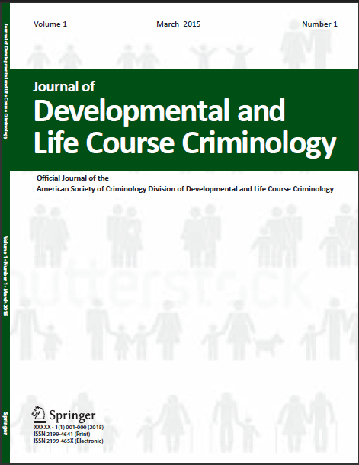

We are seeking expressions of interest for papers that advance the understanding of the complex bi-directional links between mental health and offending (including delinquency, bullying, aggression, drug offences, antisocial behavior, self-report offending, terrorism, official offending) across the life-course.

Issues that require attention in this complex are include, but are not limited to:

* How are victimisation, trauma, and childhood adversity implicated in the link between mental health and offending across the life-course?
* What developmental predictors are associated with dual harm (self and other-directed) trajectories?
* What are the causal mechanisms and shared aetiologies behind the association between mental health and offending at different life stages?
* Are childhood mental health markers of later offending replicable across time, context, cultures, and offense categories?
* Can early access to mental health care and substance abuse problems help to reduce onset, seriousness, and/or persistence of offending?
* How can the mental health needs of young offenders be addressed to support more positive outcomes?

Papers from criminology and other related disciplines such as psychology, psychiatry, statistics, sociology, neuroscience, social work, epidemiology, and public health are welcome.

Researchers interested in contributing to this special issue should submit a 250-word abstract to the journal office by 1 December 2021: [jdlcc@gre.ac.uk](mailto:jdlcc@gre.ac.uk)

Successful submissions will then be invited to submit a full paper which will undergo a comprehensive peer review process. An invitation for submission of full paper does not guarantee publication in the special issue.

Any queries about this process or the journal can be directed to the editors at: [jdlcc@gre.ac.uk](mailto:jdlcc@gre.ac.uk)

Darrick Jolliffe & Manuel Eisner

Co-Editors

Journal of Developmental and Life-Course Criminology