State-Space Grid Methodology Workshop

Sponsored by the Center on Parenting and Opioids, Dr. Tom Hollenstein will be offering a remote and free workshop next month (7/2-3) on the use of state-space grids to depict and analyze dynamic systems data, and you are welcome to join!

Why should I join?
If you’re interested in dynamic systems (e.g. how an individual responds to different situations over time, how dyads interact, group dynamics, etc.) this may be a useful method for you to depict and analyze the structure of and temporal changes within those systems. For instance, this method may be particularly relevant to developmental researchers who are looking for new and innovative ways to model parent-child interactions.

What’s a state-space grid?
Long answer provided at the workshop – but briefly, it’s a method in which various states are plotted in a two (or three) dimensional space, such that each location on the grid represents a combination of values in each of those states. Below is an example of one plotting a child and mother’s positive and negative emotional states during an interaction. State-space grids like this can help researchers identify underlying patterns at the dyadic level – for example, dyadic flexibility (as illustrated in the left pane) or rigidity (right pane) of behavior.

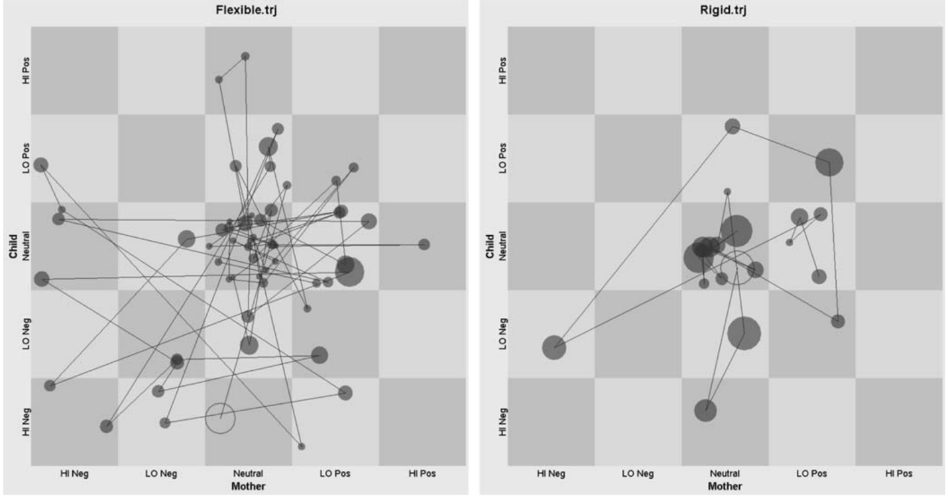

What will we do at the 2-day workshop?
The workshop will be tailored to the needs of those who register, but typically:
Day 1 (4-6 hours) provides an overview of dynamic systems concepts and a review of how state-space grids have been used. We’ll also get an introduction to the free GridWare analysis software.
Day 2 (4-6 hours) is more hands-on and devoted to working together with your own data (a dataset can be provided if you don’t have data) to come up with hypotheses, analyze and report findings to the group.

Who’s leading the workshop?
Dr. Tom Hollenstein, Professor of Psychology at Queen’s University in Ontario, is an expert in dynamic systems approaches to the study of emotion regulation and a developer of the State Space Grid methodology.

When is it?
Thursday-Friday, July 2nd and 3rd. More specific details on time and the zoom link will be provided to those who register.

Where?
In your own home! This is a remote workshop on Zoom.

How much does it cost?
It’s free! The P50 Center on Parenting and Opioids has funded it through their Training Core funds.

How do I register?
Please complete this Qualtrics survey by Thursday, June 18th 5pm to register for the workshop.

For further inquiries, feel free to contact me at: yeverett@uoregon.edu

