**Assignment: Workshop on APA Tables**

Welcome to the workshop on designing tables for scholarly writing. As a returning student, you are either a glutton for punishment or you are in the market for additional support in designing APA tables. I am pleased to be running a workshop for PREV and CPSY students for the second straight year, and I wanted to add some variety for returning students. In preparation for our time together, please complete this assignment in advance.

Below is an SPSS output from Dr. Ellen McWhirter, who has described the sample and the variables that are relevant to this output as follows:

**Sample: Latina/o High School Students attending a one-day leadership conference**

Vocational Outcome Expectations: higher scores correspond to more positive expectations about future career

Perceived Barriers to Ed Plans: Anticipated likelihood of encountering specific barriers while pursuing postsecondary plans

Self-Eff for Getting Support/Help: Confidence in ability to secure assistance with homework, help with social problems from adults, peers

English: Chose to respond to English version of survey

Spanish: Chose to respond to Spanish version of survey

***Assignment***. Please write a research question that could be addressed using data from the output below. Then, build an APA-compliant table that would be a portion of a scholarly manuscript that addressed your research question. Please send a .doc or .docx copy of your completed research question and corresponding table to [mthier@uoregon.edu](mailto:mthier@uoregon.edu) no later than 5 PM on Tuesday, Sept. 12. I look forward to working with you.

ONEWAY voemean pebmean SEsupp BY Language

/STATISTICS DESCRIPTIVES HOMOGENEITY

/PLOT MEANS

/MISSING ANALYSIS.

**Oneway (ANOVA).**

|  |  |  |  |  |  |  |  |  |  |  |  |  |
| --- | --- | --- | --- | --- | --- | --- | --- | --- | --- | --- | --- | --- |
| **Descriptives** | | | | | | | | | | | | |
|  | | | N | Mean | Std. Deviation | Std. Error | 95% Confidence Interval for Mean | | | | Minimum | Maximum |
| Lower Bound | | Upper Bound | |
| Voc Outcome Expectations | English | | 414 | 3.2498 | .78969 | .03881 | 3.1735 | | 3.3261 | | 1.00 | 4.00 |
| Spanish | | 61 | 1.6301 | .67711 | .08670 | 1.4567 | | 1.8035 | | 1.00 | 4.00 |
| Total | | 475 | 3.0418 | .94639 | .04342 | 2.9565 | | 3.1271 | | 1.00 | 4.00 |
| Perceived Barriers to Ed Plans | English | | 414 | 2.0532 | .60886 | .02992 | 1.9944 | | 2.1121 | | 1.00 | 4.00 |
| Spanish | | 61 | 2.3549 | .60341 | .07726 | 2.2004 | | 2.5095 | | 1.00 | 3.44 |
| Total | | 475 | 2.0920 | .61587 | .02826 | 2.0365 | | 2.1475 | | 1.00 | 4.00 |
| Self Eff for Getting Support/Help | English | | 414 | 3.6306 | .75884 | .03729 | 3.5572 | | 3.7039 | | 1.00 | 5.02 |
| Spanish | | 61 | 3.4960 | .92000 | .11779 | 3.2603 | | 3.7316 | | 1.00 | 5.00 |
| Total | | 475 | 3.6133 | .78160 | .03586 | 3.5428 | | 3.6837 | | 1.00 | 5.02 |
| **Test of Homogeneity of Variances** | | | | | | | | | |
|  | | Levene Statistic | | | df1 | df2 | | Sig. | |
| Voc Outcome Expectations | | 1.601 | | | 1 | 473 | | .206 | |
| Perceived Barriers to Ed Plans | | .004 | | | 1 | 473 | | .949 | |
| Self Eff for Getting Support/Help | | 3.583 | | | 1 | 473 | | .059 | |

|  |  |  |  |  |  |  |
| --- | --- | --- | --- | --- | --- | --- |
| **ANOVA** | | | | | | |
|  | | Sum of Squares | df | Mean Square | F | Sig. |
| Voc Outcome Expectations | Between Groups | 139.480 | 1 | 139.480 | 231.440 | .000 |
| Within Groups | 285.060 | 473 | .603 |  |  |
| Total | 424.540 | 474 |  |  |  |
| Perceived Barriers to Ed Plans | Between Groups | 4.838 | 1 | 4.838 | 13.081 | .000 |
| Within Groups | 174.950 | 473 | .370 |  |  |
| Total | 179.788 | 474 |  |  |  |
| Self Eff for Getting Support/Help | Between Groups | .963 | 1 | .963 | 1.579 | .210 |
| Within Groups | 288.603 | 473 | .610 |  |  |
| Total | 289.566 | 474 |  |  |  |

**Means Plots**

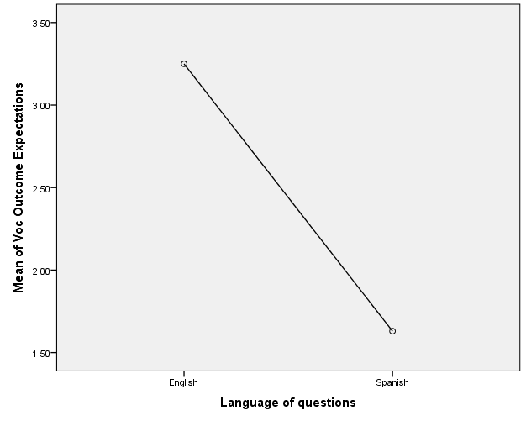

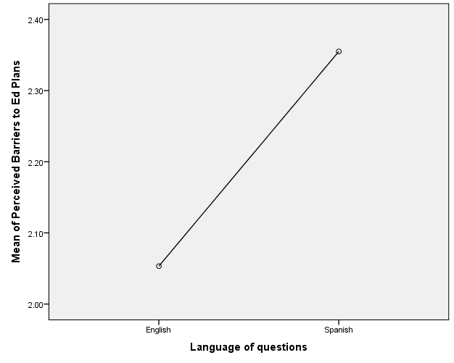

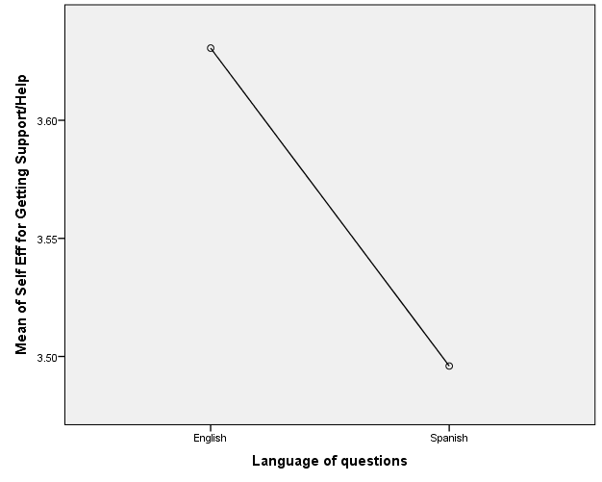

CORRELATIONS

/VARIABLES=voemean pebmean SEsupp

/PRINT=TWOTAIL NOSIG

/MISSING=PAIRWISE.

|  |  |  |  |  |
| --- | --- | --- | --- | --- |
| **Correlations** | | | | |
|  | | Voc Outcome Expectations | Perceived Barriers to Ed Plans | Self Eff for Getting Support/Help |
| Voc Outcome Expectations | Pearson Correlation | 1 | -.310** | .091* |
| Sig. (2-tailed) |  | .000 | .047 |
| N | 475 | 475 | 475 |
| Perceived Barriers to Ed Plans | Pearson Correlation | -.310** | 1 | -.054 |
| Sig. (2-tailed) | .000 |  | .236 |
| N | 475 | 475 | 475 |
| Self Eff for Getting Support/Help | Pearson Correlation | .091* | -.054 | 1 |
| Sig. (2-tailed) | .047 | .236 |  |
| N | 475 | 475 | 475 |
| **. Correlation is significant at the 0.01 level (2-tailed). | | | | |
| *. Correlation is significant at the 0.05 level (2-tailed). | | | | |

ONEWAY voemean pebmean SEsupp BY Sex

/STATISTICS DESCRIPTIVES HOMOGENEITY

/PLOT MEANS

/MISSING ANALYSIS.

**Oneway**

|  |  |  |  |  |  |  |  |  |  |
| --- | --- | --- | --- | --- | --- | --- | --- | --- | --- |
| **Descriptives** | | | | | | | | | |
|  | | N | Mean | Std. Deviation | Std. Error | 95% Confidence Interval for Mean | | Minimum | Maximum |
| Lower Bound | Upper Bound |
| Voc Outcome Expectations | Male | 173 | 3.0229 | .91413 | .06950 | 2.8857 | 3.1601 | 1.00 | 4.00 |
| Female | 297 | 3.0524 | .96321 | .05589 | 2.9424 | 3.1624 | 1.00 | 4.00 |
| Total | 470 | 3.0415 | .94457 | .04357 | 2.9559 | 3.1271 | 1.00 | 4.00 |
| Perceived Barriers to Ed Plans | Male | 173 | 2.1234 | .67100 | .05102 | 2.0227 | 2.2241 | 1.00 | 4.00 |
| Female | 297 | 2.0755 | .57203 | .03319 | 2.0102 | 2.1408 | 1.00 | 3.78 |
| Total | 470 | 2.0931 | .61006 | .02814 | 2.0378 | 2.1484 | 1.00 | 4.00 |
| Self Eff for Getting Support/Help | Male | 173 | 3.5762 | .72483 | .05511 | 3.4674 | 3.6850 | 1.67 | 5.00 |
| Female | 297 | 3.6261 | .81157 | .04709 | 3.5334 | 3.7188 | 1.00 | 5.02 |
| Total | 470 | 3.6077 | .78035 | .03599 | 3.5370 | 3.6785 | 1.00 | 5.02 |

|  |  |  |  |  |  |  |  |  |
| --- | --- | --- | --- | --- | --- | --- | --- | --- |
| **Test of Homogeneity of Variances** | | | | | | | | |
|  | | Levene Statistic | | df1 | df2 | | Sig. | |
| Voc Outcome Expectations | | .209 | | 1 | 468 | | .647 | |
| Perceived Barriers to Ed Plans | | 8.354 | | 1 | 468 | | .004 | |
| Self Eff for Getting Support/Help | | 2.368 | | 1 | 468 | | .125 | |
| **ANOVA** | | | | | | | | | | | |
|  | | | Sum of Squares | | | df | | Mean Square | | F | Sig. |
| Voc Outcome Expectations | Between Groups | | .095 | | | 1 | | .095 | | .106 | .744 |
| Within Groups | | 418.353 | | | 468 | | .894 | |  |  |
| Total | | 418.448 | | | 469 | |  | |  |  |
| Perceived Barriers to Ed Plans | Between Groups | | .251 | | | 1 | | .251 | | .673 | .412 |
| Within Groups | | 174.296 | | | 468 | | .372 | |  |  |
| Total | | 174.547 | | | 469 | |  | |  |  |
| Self Eff for Getting Support/Help | Between Groups | | .272 | | | 1 | | .272 | | .446 | .505 |
| Within Groups | | 285.325 | | | 468 | | .610 | |  |  |
| Total | | 285.597 | | | 469 | |  | |  |  |

**Means Plots**

