PI Proxy submission – One of the PI proxies on the research team submitted a response to the IACUC.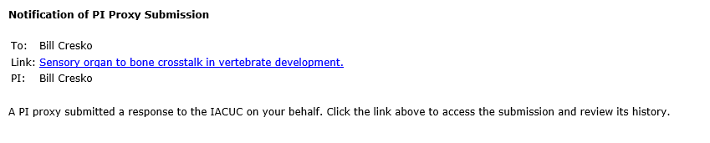

Requested clarifications – the IACUC has requested additional information that requires a response from you.
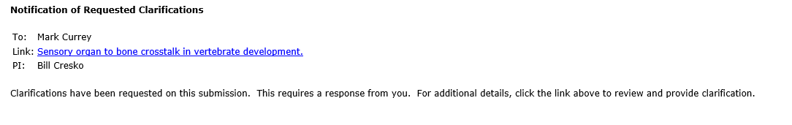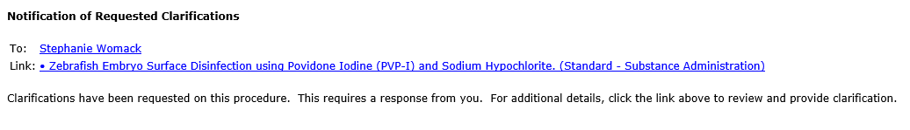

Triennial review deadline – the Triennial review is due for your protocol (de novo review every three years). User should submit Triennial review prior to deadline.
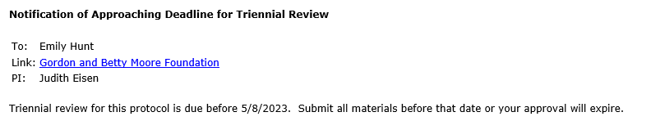

IACUC staff submission – the IACUC submitted an amendment on your behalf.
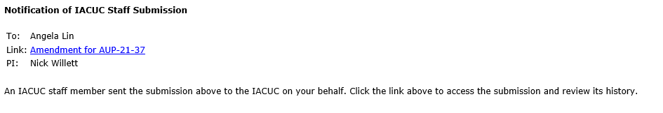
Approved – the amendment has been approved by the IACUC.
