Outline of Training Content & Key Messages

Terminology Suggestions
- Use these: larger body, higher body mass index, higher weight, fat
- Not these: overweight, obesity, severe obesity
- Ask about the language people prefer.

Learning Objectives

Intersecting identities
- The ultimate goals of our workshop are to shift the biases that underlie stigmatizing experiences and, in doing so, reduce the discrimination.
- Experiences of body size bias and discrimination intersect with other forms of discrimination. For example, Black women experience some of the worst healthcare in this country. If these women also have larger bodies, you can see how discrimination related to body size and racism compound one another.

Body size bias
- The belief that people in larger bodies are “unhealthy” is one of the most common and problematic forms of weight bias.
- Stereotypes matter because for people in larger bodies, they promote blame, a sense of social distance, and rejection from others. They also drive discrimination.

Body mass index (BMI) & health outcomes
- The data show a consistent J shape in the associations between BMI and poor health outcomes, with people in the “overweight” category consistently showing the lowest mortality and health risks.
- The experiences of bias and discrimination predict poor physical and mental health outcomes, controlling for BMI.
- Social support (low vs. high), smoking, alcohol use, flu vaccination, and physical activity are better predictors of life longevity than BMI.

Sources of body size bias
- There are so many, including the media, advertisements, children’s movies and books, weight loss, beauty, and wellness industries, family and friends, and medical communities.
- Weight is the #1 reason children are teased by their peers.
- Families are the #1 perpetrators of weight bias and discrimination, often in the form of good-intentioned comments related to weight loss and eating less food.

Body size discrimination
- Bias often leads to unfair treatment of people in larger bodies.
- Discrimination based on body size happens across the many settings in which we live, work, and learn.

Poor outcomes associated with body size discrimination
- Mental health examples: higher stress, depressive symptoms, psychiatric disorders, substance use disorders, and suicidality, poorer body image, and lower self-esteem.
- Physical health examples: higher rates of binge eating and physical activity avoidance, higher cholesterol and cortisol levels, worsened outcomes for those with chronic diseases, and 60% increased risk of premature death.
- These negative impacts on health are not explained by body size. The research that has identified these links accounted for body mass in their studies.

Body size discrimination prevalence
- Body size discrimination is more prevalent than discrimination based on ethnicity, sexual orientation, and physical ability.
- Implicit biases have been decreasing related to sexual orientation, race, skin tone, age and disability. Whereas implicit bias related to weight has increased.

Body size bias, control, & rejection
- When we assume body size is simply a matter of dietary intake and physical activity, it contributes to a culture of blame and unfair treatment of people in larger bodies.

Complex, multilevel contributors to body size
- Body size is determined by a complicated system of factors that interact with each other such as, genetics, our environment (including how we work, live, and play), the food in our communities and homes, school lunch and recess policies, access to health insurance, eating and physical activity.
- Our bodies and brains resist the maintenance of weight loss.

Action steps to address body size bias and discrimination
- Step 1: Reflect
  - Having an honest conversation with yourself about underlying beliefs that may negatively influence your workplace decisions or interactions with others is a first step toward promoting equity.
  - Consider how you talk about your body. Do you focus on how you wish your body were different or do you respect what it does for you? Do you openly talk about your weight loss goals? Do you make disparaging comments about your body?
  - Listen to what your family members are saying about weight and body size. Is what they’re saying reinforcing body size bias?
  - Question whether biased beliefs align with your values.
- Step 2: Take Action
  - Advocate for Policies:
    - Prohibit financial penalties, via health insurance or otherwise, imposed on people with larger body sizes.
    - Adopt a policy that disallows the use of an applicant’s or employee’s body size in employment decisions (e.g., hiring, performance evaluation) without a determination that body size is relevant to the job.
    - Implement interview practices that minimize the influence of subjective biases (e.g., telephone interviews).
    - If certain traits or skills are pertinent to the hiring process, require use of validated measures to assess these traits/skills.
    - Require instruction specific to body size bias, such as scientific evidence that refutes stereotypes and quantifies discriminatory practices, in diversity trainings for those involved in hiring and performance evaluation processes.
    - Involve people with a variety of body sizes in all decision- making processes.
  - Use your voice:
    - Point it out when you see it (most applicable to those in leadership roles and who have privilege/power).
    - Dispel myths when you hear them.
    - Use more inclusive language when talking about body size (preferred terms are larger body size and higher BMI, rather than overweight, obese, fat, or conflating body size and health).
    - Generally, adopt the language preferred by others.
  - Shift the focus:
    - The messages you share in the classroom, in wellness promotion initiatives, and with co-workers can encourage healthy behaviors without once mentioning weight or size
    - Increase opportunities for building connections with others
    - Increase opportunities for fruit and vegetable intake and physical activity
    - Improve access to a variety of foods
    - Improve sleep hygiene
    - Engage in stress reducing activities
    - Focus on how systems can support health (e.g., food access)
  - Create a more inclusive workplace and classroom environment:
    - Include size in written and verbal descriptions of diversity (e.g., syllabus statements: see resources).
    - Include photos of size diverse people in slides or remove photos of bodies all together.
      - https://theadipositivityproject.zenfolio.com/all (includes nudity)
      - https://bodyliberationphotos.com/
      - https://uconnruddcenter.org/media-gallery/
    - Include scholarly and creative works of people with larger body sizes.
    - Do not tolerate teasing, name-calling, or bullying for any reason.
    - Provide larger sizes in lab coats, t-shirts, etc. or opt for alternatives to restrictive clothing as a way to identify someone’s role or inclusion in a group.
    - Advocate for a classroom with chairs with non-attached desks.
    - Take a look at the extra chair in your workspace, would students and
co-workers with larger body sizes be able to comfortably sit in them?

Questions? Reach out to therenewlab@uoregon.edu

Resources
National Association to Advance Fat Acceptance:
https://naafa.org/
NAAFA is a volunteer run fat right’s advocacy group. They are a larger and long running group with a website full of educational and legislative tools to help increase rights for fat people. It also has resources for community connection and small community-based grants for projects which seek to improve the lives of fat people.

“Don’t Weight Me” Cards
https://more-love.org/resources/free-dont-weigh-me-cards/
To consider using on your own and/or to share with your provider.

Rudd Center:
http://www.uconnruddcenter.org/weight-bias-stigma
The Rudd center is a non-profit organization which focuses on research based solutions to “childhood obesity, poor diet, and weight stigma”. Their website contains a section dedicated to reduction of weight stigma through providing resources like policy briefs, educational videos, and information about weight bias in health providers.

Council on Size and Weight Discrimination:
http://cswd.org/
CSWD is another nonprofit focused on changing public policies which discriminate against people with larger bodies, especially in the areas of medical treatment, media, and the workplace. The website has a large list of statistics about workplace discrimination and suggestions about how to write advocacy letters.

Advocacy letter template:

“Dear [insert name of state representative/governor/city council/president of university]
Discrimination based on larger body size has increased and continues to increase in the United States, with some studies finding current rates of reported discrimination based on body size to be as high as racial discrimination; especially among women. Many people believe stereotypes that people with larger body sizes are lazy or unhealthy, which fuels discriminatory practices across many settings. With roughly two-thirds of the U.S. population considered to overweight or obese, many people are vulnerable to the negative effects of such discrimination. Weight discrimination is especially harmful in educational settings because it perpetuates social and economic inequities for students of larger body sizes. Students with larger body sizes are more likely to receive [insert examples from ed slides], than their classmates with smaller body sizes. This discrimination remains legal in all but one U.S. state and a handful of cities. Only Michigan has begun to take the necessary steps to protect its overweight citizens from social and economic inequity by including body size as a protected class.
The public wants you to take a stand. There is broad support among the U.S. population for policies that protect people and reduce discrimination based on weight. Approximately, 65% of men and 81% of women support laws that would prohibit weight discrimination. There is an opportunity here for [insert state/city/organization] to join leaders in social justice reform. I ask that you [name] put forth [legislation/policy proposal] which makes it unlawful to discriminate in educational settings on the basis of weight or body size, including [insert ed examples] based on body size. Too many students in this country face unchecked discrimination based on harmful and false stereotypes. I urge you to be a pioneer in their protection by beginning what will be a well-supported process of creating lasting legal and policy change that many other [schools/institutions of higher education] can look to as a model.
Thank you,
[insert full name and contact information]”

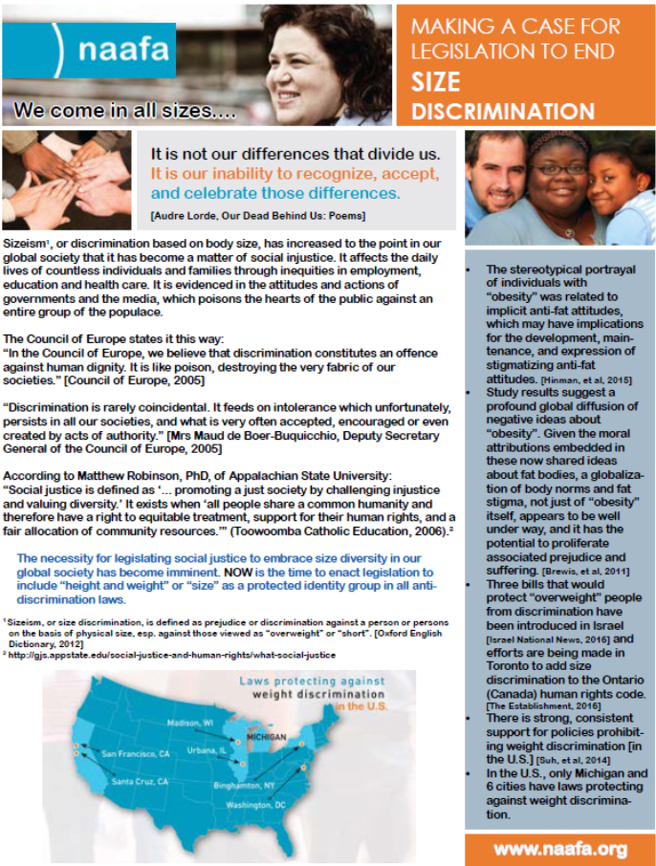
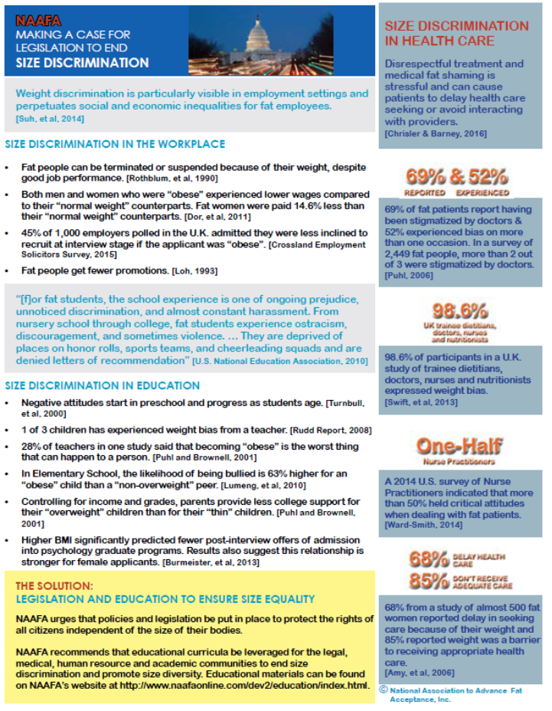

Syllabus example language:

Weight-based stigma statement

“Discrimination based on larger body size is an often underrecognized issue facing many students. I acknowledge the harmful impact of fatphobia and weight-based stigma on students. I will work to advance social justice by creating an inclusive and respectful community that is supportive of people of all sizes. I will do what is within my power to remove weight bias in my classroom by providing size inclusive physical environment, honoring body diversity, and continually challenging body size bias and discrimination in myself, my curriculum, and expressed by students and faculty.”

Incorporate body size language in general anti-discrimination statements:

“In this course, class discussions, projects/activities and assignments will challenge students to think critically about and be sensitive to the influence, and intersections, of race, ethnicity, nationality, documentation, language, religion, gender, socioeconomic background, physical and cognitive ability, body size, sexual orientation, and other cultural identities and experiences. Students will be encouraged to develop or expand their respect and understanding of such differences.

Maintaining an inclusive classroom environment where all students feel able to talk about their cultural identities and experiences, ideas, beliefs, and values will not only be my responsibility, but the responsibility of each class member as well. Behavior that disregards or diminishes another student will not be permitted for any reason. This means that no racist, ableist, transphobic, xenophobic, chauvinistic, fatphobic or otherwise derogatory comments will be allowed. It also means that students must pay attention and listen respectfully to each other’s comments.”

