**Student Affiliates of Seventeen (SAS) Executive Board Application ‘21–‘22**

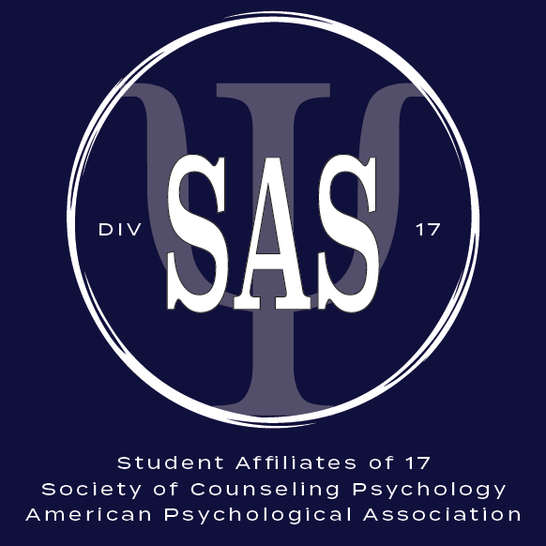

The following is an application to serve as a member of the Executive Board for Student Affiliates of Seventeen (SAS), the student organization of the Society of Counseling Psychology (APA Division 17). Doctoral and master’s students may serve in these roles. Serving as a SAS Executive Board member entails weekly obligations and is a substantial leadership, professional development, and service and advocacy opportunity. Each board member serves in a specialized role. **Full descriptions of the available positions are available** [**here**](https://docs.google.com/document/d/1peualtE5kbf2NFdN5EBmZPwu0eGOwEsvphNrdw5IeLk/edit)**. Please review these descriptions fully before applying.**

**Application Checklist**



☐ Application of Intent (this form, **3 pages**)

☐ By checking this box I agree to a one-year term.

☐ CV or resume

☐ Statement of Good Standing (email): *Your advisor or program director must send a brief email to the SAS Tri-Chairs at* div17SAS@gmail.com *verifying your status as a graduate student in good standing and their support for you for consideration for a position on the SAS Executive Board.*

Please send completed application materials and any questions regarding this application to the *SAS Tri-Chairs at* div17SAS@gmail.com.

**Personal Information**



Applicant Name:

Address:

Email:

Phone:

Gender:

Race/ethnicity:

International student?:

First-generation and/or low-income background?:

Other salient personal identities you would like to share:

**Academic Information**



University:

Program:

Degree type (master’s, PhD, PsyD):

Year in the program:

Expected Graduation:

**Division Information**



☐ I am a current member of SAS (i.e., student affiliate of APA Division 17) or will be enrolled as a student affiliate of Division 17 by the time I accept the position of SAS Executive Board member should I be selected. This is a requirement UNLESS you applied to the SAS Emergency Fund in July 2020. If you are unsure of your student affiliate status in Division 17, please follow these steps:

* Visit <https://my.apa.org/apa/idm/login.seam?ERIGHTS_TARGET=/portal/home.seam> and enter your APA username and password.
  + If you need to recover your APA username or password, or verify that you have an APA account, visit <https://my.apa.org/apa/idm/memberLoginSearch.jsf>
* Once logged in, scroll down the home screen until you see the section titled “APA Groups & Affiliations” (example below). If you are signed up as a student affiliate of Division 17, Society of Counseling Psychology (SCP) will be listed.
* If you do not see SCP listed, you can enroll as a student affiliate at this link. Annual dues for the division are $17: <https://join.apa.org/divisions?division=17>

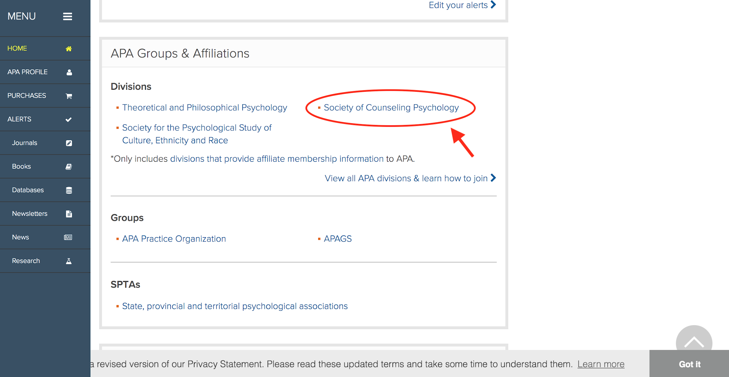

**Application Questions**



**Please rank the top available positions on the ‘21–‘22 SAS Executive Board for which you would like to apply, beginning with the position of greatest interest to you. You may rank up to three positions. Please review the** [**position descriptions**](https://docs.google.com/document/d/1peualtE5kbf2NFdN5EBmZPwu0eGOwEsvphNrdw5IeLk/edit) **for open positions completely before applying.**

1.

2.

3.

**Please describe your anticipated weekly availability to commit time to service in your role on the SAS Executive Board.**

**Briefly (in 3–10 sentences), what strengths would you bring to the position(s) to which you are applying and to the SAS Executive Board overall? If you are applying for more than one position and have strengths relevant to specific positions to which you are applying, please specify how you view these as relevant to particular roles.**

**Briefly (in 3–10 sentences), how would you be excited to see SAS engage and support counseling psychology and counseling students in ‘21–‘22?**