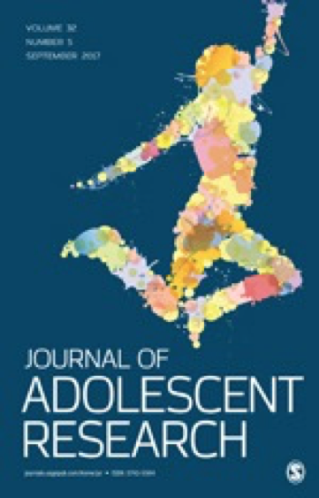 | Call for Papers  Submission Deadline:  Optional abstracts due: October 31, 2020  Full manuscripts due: January 15, 2021  Journal of Adolescent Research Special Issue:  Critical approaches to adolescent development: Reflections on theories and methods for pursuing anti-racist developmental science  Guest Editors:  Leoandra Onnie Rogers, Joanna Lee Williams, Mariah Kornbluh

In response to the continued assault on Black and Brown lives, and recognition of the role that science, including developmental science, has played in supporting and furthering narratives that uphold white supremacy, the Journal of Adolescent Research is planning a special issue entitled “Critical approaches to adolescent development: Reflections on theories and methods for pursuing anti-racist developmental science.” This special issue responds to recent calls for increased focus on the role and responsibility of developmental scientists in pursuing racial justice.

In this special issue, we will open up space for consideration of methodological and theoretical manuscripts that may or may not draw on empirical data to make their arguments. Theory and method translate to ways of “seeing” and “doing” science. The focus on method and theory acknowledges the fact that the field of adolescent development needs a deeper and more critical interrogation of the ways in which we conceptualize adolescents and their development - how we “see” them - as well as the tools we use to collect and analyze our data - how we “do” research with them. The methodological focus also aligns with a focal aim of JAR as a journal that offers a venue for qualitative and mixed-methods, methods that have been historically marginalized and discounted within developmental science. We envision including empirically-based manuscripts that use data to demonstrate new methodological and theoretical ways of doing our work, we also envision accepting articles that seek to construct new frames, highlight innovative methodological approaches, or critique existing approaches from a more theoretical stance.

Topics of interest to this special issue may include, but are not limited to:
- Innovative methods, new measure development techniques, including empirical examples of novel measures or analysis techniques that provide researchers with the tools to pursue antiracist developmental science
- New research questions that push existing theories and reflect the aims of anti-racist developmental science
- Exploration of the ways in which dominant theories, disciplinary boundaries, and methodologies/methods may reify and amplify structural racism. This may include offering up new frames for our research.
- Data-driven discoveries that influence antiracist developmental theories and/or method
- Participatory and youth-led research surrounding antiracism efforts

We imagine this special issue to function as critical self-evaluation for the field of adolescent development, questioning and unpacking existing theory and methods. Such critique is toward the goal of innovation and action, and thus we seek articles that closely thread critique with practical suggestions and alternatives and possibilities for the readership to pursue antiracist developmental science.

For details about the aims and scope of the Journal of Adolescent Research (JAR) please see our website: https://journals.sagepub.com/aims-scope/JAR.

Optional abstract submission deadline is October 31, 2020. Authors submitting abstracts will be provided feedback in mid-November. These manuscripts will be given priority in the review process (although submission of an abstract does not guarantee acceptance in the final issue). Abstracts should be a maximum of 500 words and follow APA guidelines. Abstracts should be submitted via email to: NDeutschJAR@gmail.com. Subject line: Antiracist Special Issue Abstract.

Submission deadline is January 21, 2021 for full manuscripts. All manuscripts should be submitted through the Scholar One website and follow the usual JAR submission guidelines, which can be found here. In your cover letter, please indicate that this is a submission for the special issue on Critical Approaches to Developmental Research.

