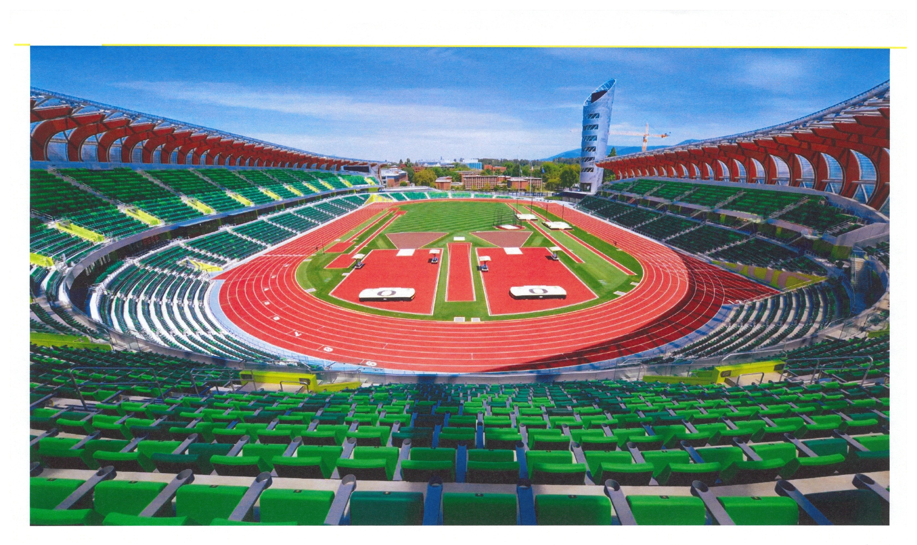

Students and faculty will be seated on the field. The blue rectangle represents the stage; the black lines the rows of seating.
The Stage Party, Faculty and Students will line up in the practice/locker room areas underneath the stadium.

Guests will be in the south part of the stadium (the end opposite the tower). This photo is their view of the field.

Not to scale

