

Where Kids Can!
KidTherapy is looking for an energetic, passionate, and motivated Speech Therapist to join our team! Therapist will evaluate and treat children and teenagers of all ages with a variety of diagnoses. At KidTherapy, PTs, OTs, and SLPs, work together to develop & execute individualized care to help families reach their goals. Bilingual is a plus!!


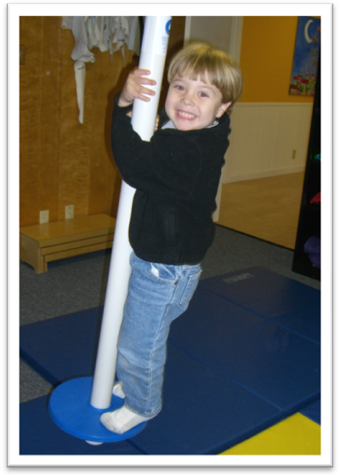

Full time, part time, and PRN positions are available. Flexible hours and competitive pay also offered. Benefit package available for full time employees.
Get more information about us at: www.kidtherapyaustin.com or call (512) 916-1511.
Please fax resumes to (512) 916-1532 or e-mail to kidtherapycareers@gmail.com. We are located two blocks south of US highway 71 in South Austin.

