**SLP POSITIONS AVAILABLE IN SOUTHERN VERMONT**

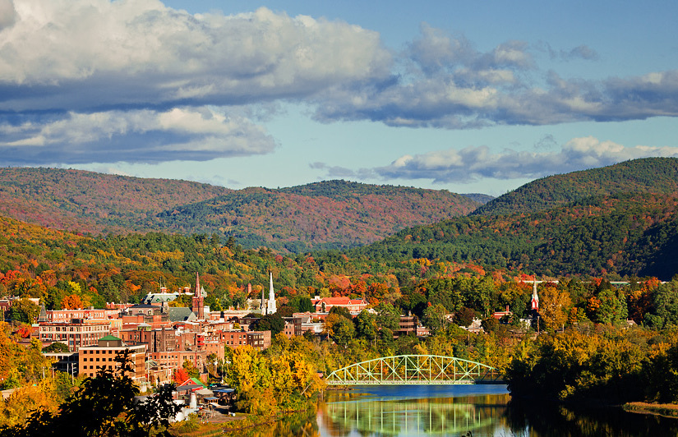

Come work in beautiful southeast Vermont beginning September 2020-21 school year. Windham Southeast School District in eclectic Brattleboro area is seeking 2 SLP-CCC or CF candidates for pre-k -12. SLPA candidates also considered. Come join our team of SLPs providing evaluation, direct, consultative and collaborative speech-language therapy in the areas of articulation, language development, fluency, AAC, and social language skills.

**Manageable caseloads, competitive salary and excellent benefits**.

Resume and three letters of reference to: Marisa Duncan-Holley, Director of Special Education, 53 Green Street, Brattleboro, VT  [mdholley@wsesdvt.org](mailto:mdholley@wsesdvt.org)

Located near;  Boston, New York City, Montreal and more…

We are a four season town boasting a vibrant music and art scene and active outdoor community in a picturesque setting.