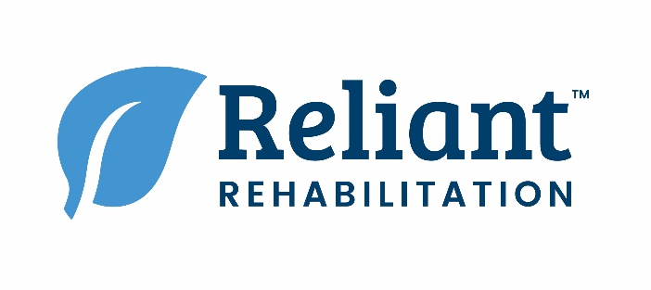

**PRN AND FULL TIME SPEECH LANGUAGE PATHOLOGISTS AND/OR CFY’S**

**Angleton, Bay City, Big Spring, Brownwood, Coleman, Colorado City, Eastland, El Campo, Ganado, Gonzales, Kerrville, Moulton, Pleasanton, Rockdale, San Angelo, San Antonio, Schulenburg, Shiner, Sweetwater, Uvalde, Victoria, Winnie, Yoakum**

***\*\*\*SIGN-ON BONUS IS AVAILABLE AT SOME OF THESE LOCATIONS\*\*\****

Reliant has had phenomenal growth in the past several years, and we are already on track for more in 2019. We grew to become the largest privately held rehabilitation management company in the field of post-acute care providing Physical, Occupational and Speech Therapy services to more than 37,000 patients daily across the U.S. Reliant has over 9,000 employees across 940+ facilities and customer operations in 40 states. We are seeking talented, passionate professionals who believe in quality patient care to interview immediately for our therapy positions throughout our locations! We provide therapy in settings such as Acute Care Hospitals, Skilled Nursing Facilities, Sub Acute Facilities, LTACHs, Rehab Hospitals, and CCRCs across the United States. If you’re interested or would like to know more about the positions, please feel free to reach me-972-832-2269 or [dryan@reliant-rehab.com](mailto:dryan@reliant-rehab.com).

* **Paid Time Off**
* **401k Plan**
* **Ongoing Clinical Support**
* **Life Insurance**
* **Short Term & Long-Term Disability Insurance**
* **Medical, Dental, and Vision Insurance**
* **Licensure Reimbursement and Unlimited CEU’s through CEU360**
* **Competitive Rates/Salaries**
* **Model 10: Revolutionary Clinical Model**
* **Career Advancement – Management Track**

**Program**

* **Relocation assistance available**

If you’re a current full time Reliant employee this is not meant to solicit you from your current position, but a means to network with you only.

DISCLAIMERY

**RELIANT REHABILITATION IS NOW HIRING!**

BENEFITS SUMMARYY

CONTACT

**Darla Ryan | Talent Acquisition Specialist**

Phone: (972)-832-2269

Email: [dryan@reliant-rehab.com](mailto:dryan@reliant-rehab.com)