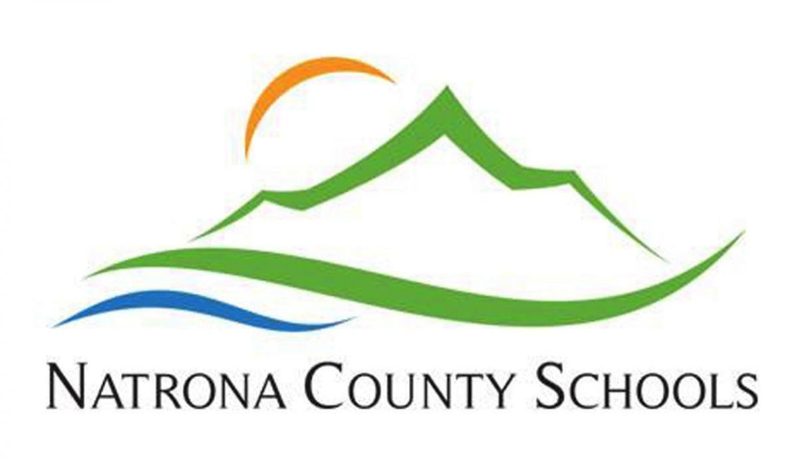

For more information go to www.natronaschools.org and click on the careers tab, or contact Ted Hanson or Norm Cox at (307) 253-5480.

To apply for this position please complete the online application process at www.natronaschools.org by clicking on the careers tab and going to the recruitment management link to create a username and password. In addition to this, please send a letter of interest and a resume to Ted Hanson or Norm Cox at 970 N. Rd. Glenn, Wyoming 82601

Natrona County School District is committed to providing optimum learning opportunities for every child. We know that today’s students need far more than the traditional reading, writing, and arithmetic lessons. In NCSD, we strive to provide all students with optimum learning opportunities and the tools, skills, and knowledge they will need to be successful in the 21st century.

Looking for a job in Speech-Language Pathology?

Natrona County School District, located in Casper, Wyoming, is seeking a full time Speech-Language Pathologist for the 2018-2019 school year.

Benefits Include:

* Retirement Plan
* Life Insurance
* Health Insurance
* Sick Leave
* Personal Leave
* Competitive Salary
* Continuing Education Opportunities

Qualifications:

* Masters Degree
* ASHA Certified (CF opportunities available)