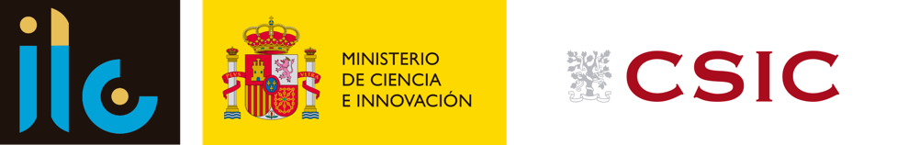 | Institute of Languages and Cultures of the Mediterranean and the Near (ILC)  Centre for Human and Social Sciences (CCHS)  c/Albasanz 26  28037 Madrid

Pre-Call/Expression of Interest (EoI)

The Institute of Languages and Cultures of the Mediterranean and the Near East (ILC) has as its main objective the study of the languages and cultures of the Mediterranean basin and its adjacent areas, based on the original texts and from a multidisciplinary perspective.

PROJECT: West of Eden (WE): Muslim and Jewish Cultures in the Western Mediterranean (13th-17th centuries) (2025-2029)

DESCRIPTION: West of Eden (WE) is seeking applications for two postdoctoral research positions to be offered in the CSIC’s Labour Exchange from September/October 2025. A researcher in Jewish studies and a researcher in Cultural History are required. Both will work in collaboration with the PI of the project on the different work packages, which include among other the tasks of selection and analysis of sources, the elaboration of a digital catalogue, the publication of articles and participation in seminars and conferences, as well as the dissemination of the key activities of the project.
WE will critically question the boundaries between Muslims and Jews in the Western Mediterranean. Their relations represent some of the most pressing challenges to the cohesion of plural societies and the integration of religious minorities today. In turn, historical sources reveal the deep interconnectedness of Jews and Muslims, documenting how they met, intermingled and opposed each other over the centuries, and offer a unique way of understanding inter-religious dynamics in what would become modern Europe and its colonies. The project will address the study and interpretation of practices, ideas, patterns, continuities and changes in the articulation of Muslim and Jewish identities in contact, identifying four essential aspects of cultural and religious co-production in contested “discursive sites” (textual production; emic knowledge; geographies of contact; religious and community practices). We will work with manuscript sources, archival sources, artefacts, talismans, epigraphy and archaeological remains to acquire data on practices and modes of thought in areas of Jewish-Muslim convergence. Within the boundaries of the pre-modern western Mediterranean, individuals and groups interacted closely, but these boundaries also functioned as a stage on which their differences were accentuated. Scholars have noted that when intimacy and conflict intersect, complex modes of intellectual and cultural co-production emerge between Jews and Muslims.
The main aim of WE is to identify and explain the most salient practices, beliefs and ideas that emerged in those in-between spaces, where mutual and self perceptions of Jews and Muslims were negotiated. The specific aims will be to establish a corpus of Muslim and Jewish sources for the study of their groups’ intertwined religious and cultural practices, to identify key processes of sharpening and crossover between their groups in specific contexts and networks, and to develop a conceptual framework to explain the contours and stakes of their in-between spaces. Expressions of interest need to be framed along these lines.

CONDITIONS OFFERED:
- Postdoctoral contract for the duration of the project, 2025-2029
- Selection and recruitment: through the CSIC’s Labour Exchange
- Start date: September/December 2025

REQUIREMENTS:
- To meet the requirements for employment in the CSIC
- PhD in the area of knowledge of the activities to be carried out
- Autonomy, ability to work in a team and social skills

Other aspects to be assessed:
- Proficiency in Hebrew for the candidature in Jewish studies
- Training and/or knowledge of Arabic, Islam, Medieval History and/or Social and Cultural Anthropology
- Familiarity with critical theories of culture and codicology
- Fluency in English (level C1 or equivalent)
- Knowledge of other languages of the medieval Mediterranean basin (Catalan, French, Portuguese, Italian, Latin, ... )

SENDING EXPRESSIONS OF INTEREST:
Interested candidates are invited to register in the CSIC’s Labour Exchange and to send a CV, one letter of recommendation, and a cover letter/motivation (maximum 2 pages), detailing the interest and how the candidate meets the proposed requirements to the PI Mònica Colominas Aparicio, m.colominas.aparicio@rug.nl with the SUBJECT: ‘Call for applications West of Eden + Name and Surname of the candidate’. For requests, please contact through the same email with the SUBJECT: ‘Call for applications West of Eden: request’.

